ENCLOSURE 2
BOOKING FORM
ACCOMODATION
The rates negotiated with the partner hotels will be applicable by mentioning the code “PAN 2024” only.
Prices have been negotiated (accommodation + breakfast). For catering, the hotel awaits your requests.
The organiser does not manage bookings; you must contact the hotel directly.
Country:
Club or Federation:
Telephone: | Fax: | e-mail:

Please complete: | Number of Rooms | Date
 |  | From | To
Single
Double / Triple
 | Number of Rooms | Date
 |  | From | To
Single
Double / Triple

 | Date:
(President Signature / stamp) |  | (Full name in block letters)

Adress | Price | Pictures
Novotel Aix Beaumanoir  Rue Marcel Arnaud  13100 Aix en Provence  +33 4 42 91 15 15  H0393-FO1@accor.com |  | 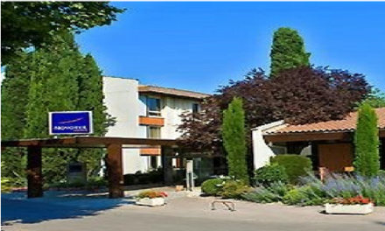
Campanile  1 rue Jean Andreani  13090 Aix en Provence  +33 4 42 26 35 24  aix.pontdelarc@campanile.fr |  | 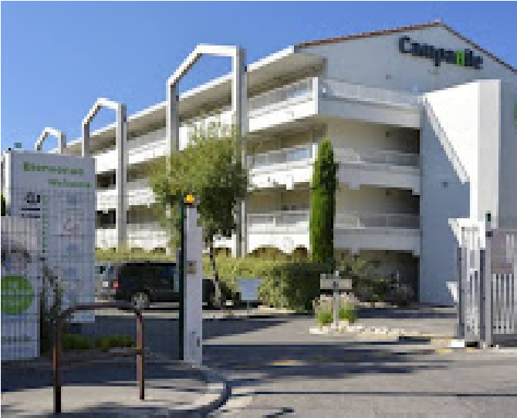
Novotel Pont de l’Arc  Avenue de l’Arc de Meyran  13100 Aix en Provence  +33 4 42 16 09 09  H0393-FO1@accor.com |  | 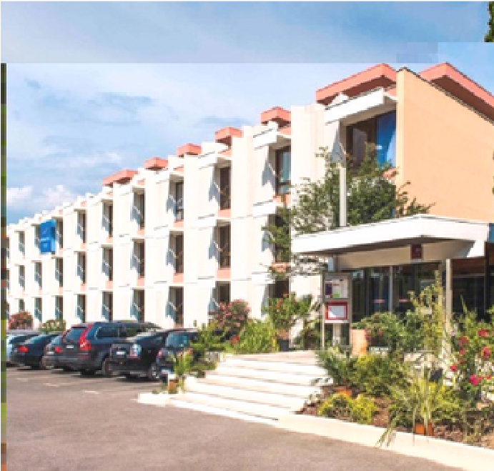
Campanile Aix en Provence Est – Meyreuil  P.A Technologiques de  La Sainte Victoire  13590 MEYREUIL  +33 4 42 58 69 69  aix.meyreuil@campanile.fr |  | 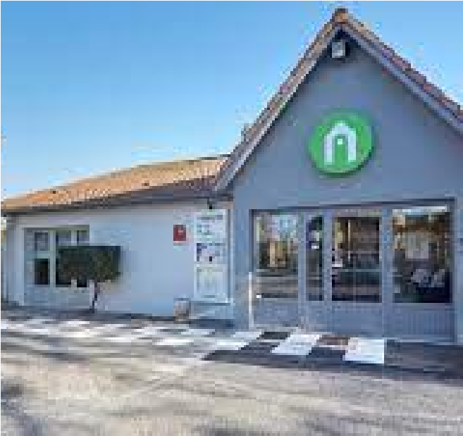
Hôtel Escale Oceania Aix-  en-Provence  12 Av. de la Cible, 13100  Aix-en-Provence  +33 4 42 37 58 5 8  escaleoceania.aix@oceaniahotels.com |  | 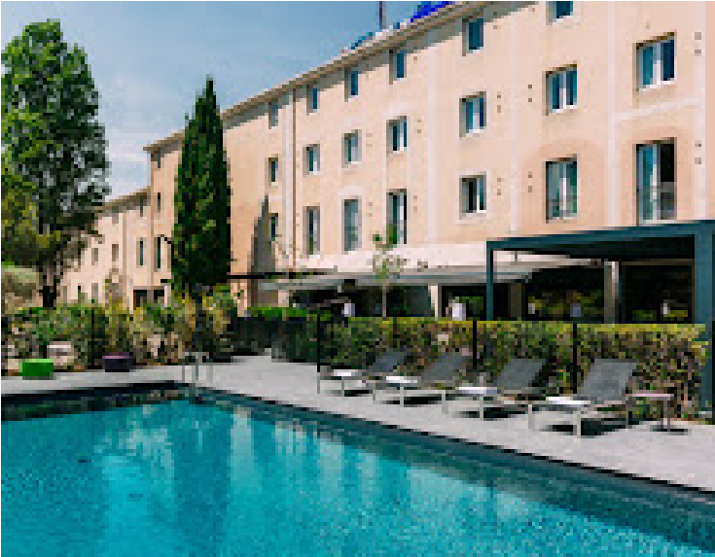
Ibis Aix  Avenue des infirmeries  13100 Aix en Provence  +33 4 42 27 98 20  H0714@accor.com |  | 